Instructions for PC Users:

- Save the new background image (jpg) to your desktop or a folder of your choice.

- Open your presentation and click on the "Design" tab.

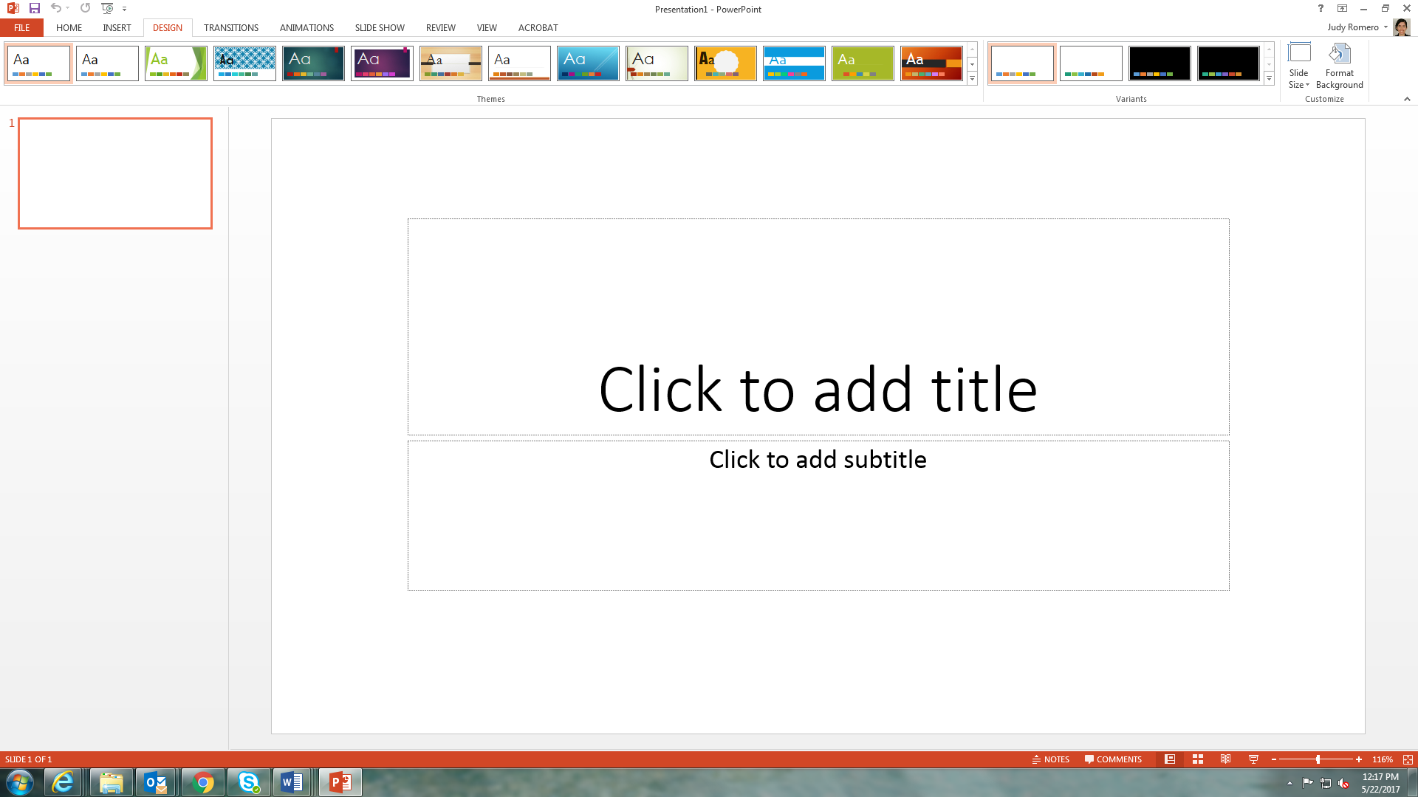

- Click “Format Background” in the top right.

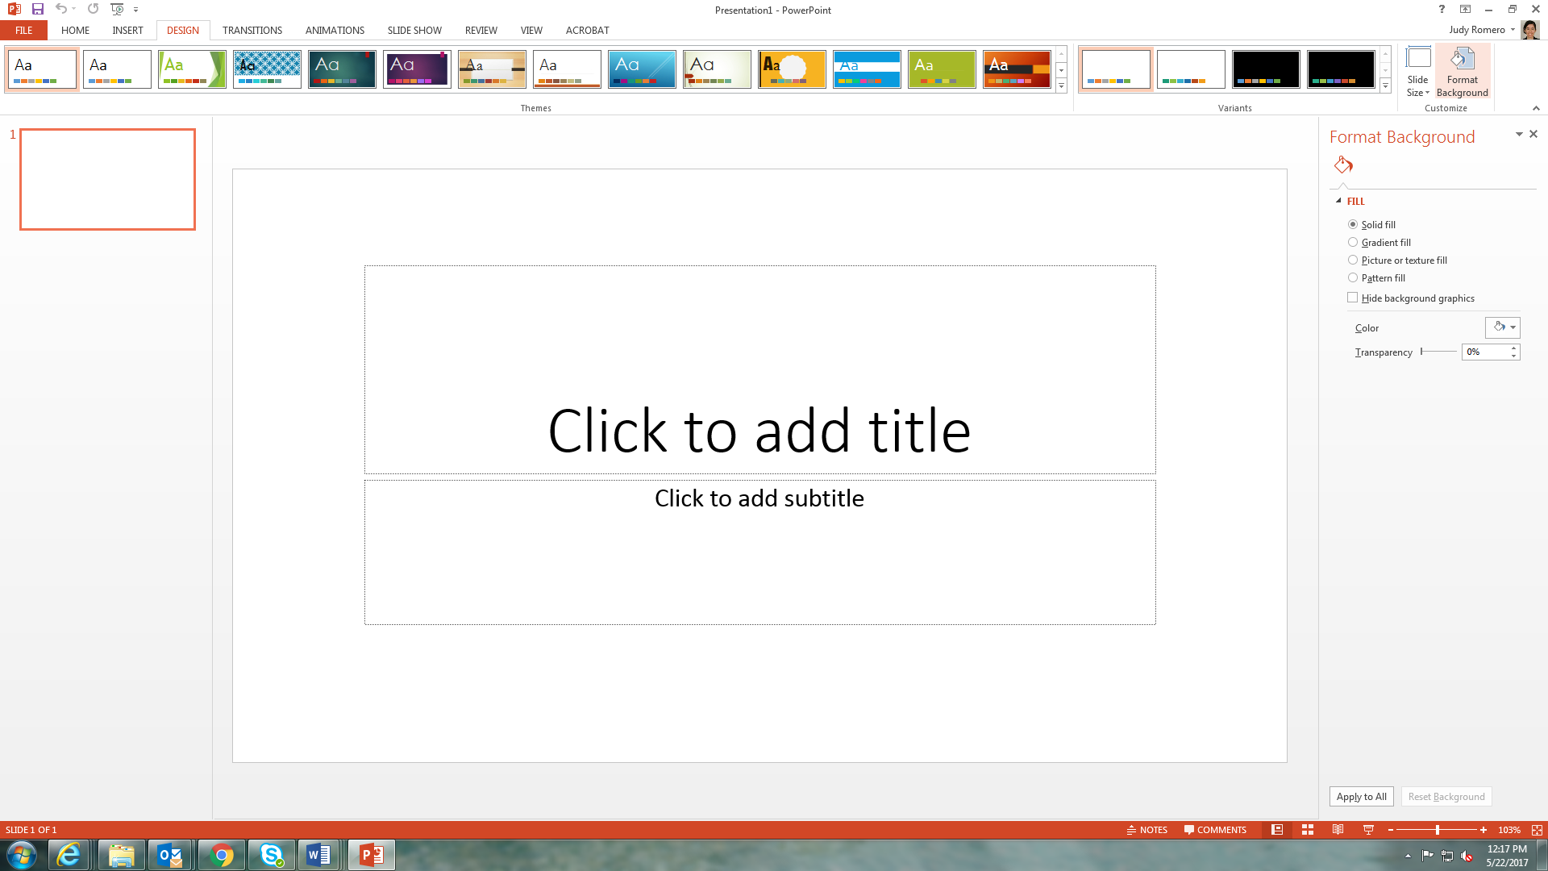

- A new view will appear. In the right-hand menu, click on “Picture or texture fill.”

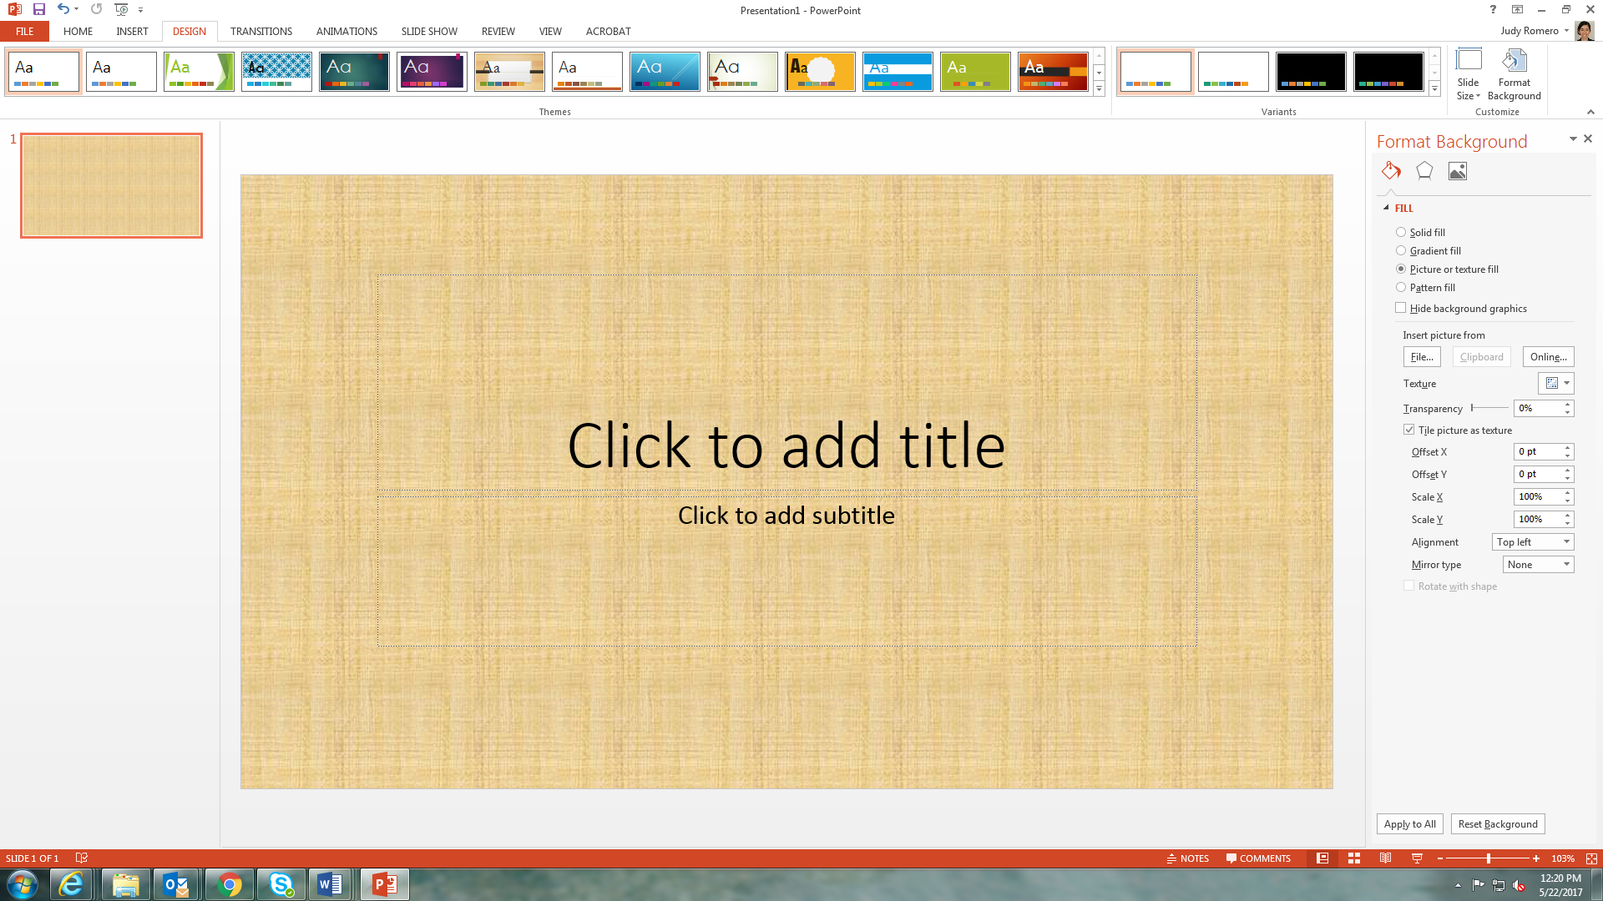

- Below, click on “File,” browse to the folder where the new background is saved, and select the desired image.’

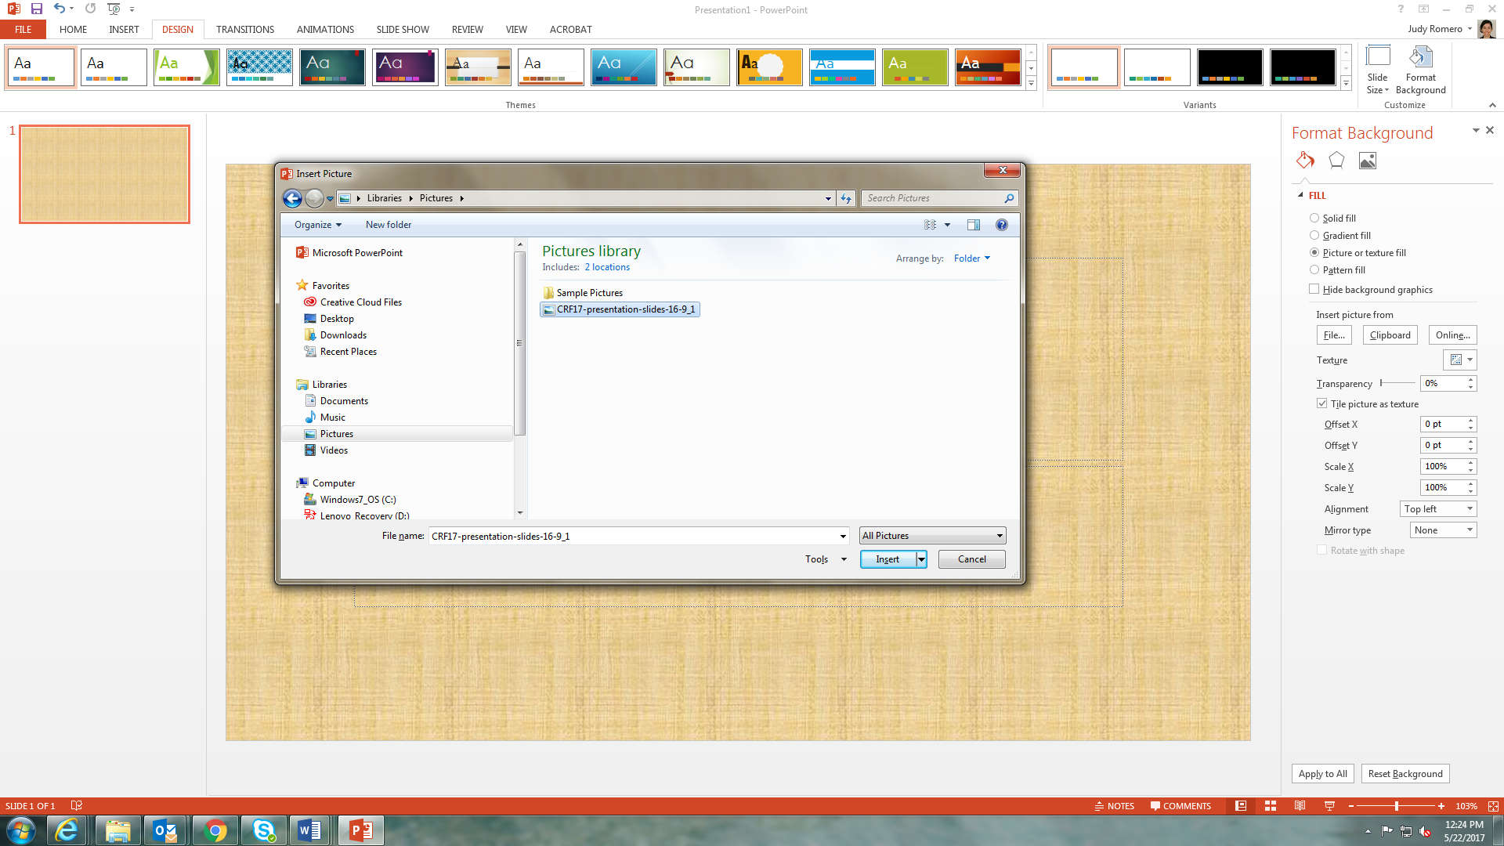

- The background will appear behind in the slide (to the left).

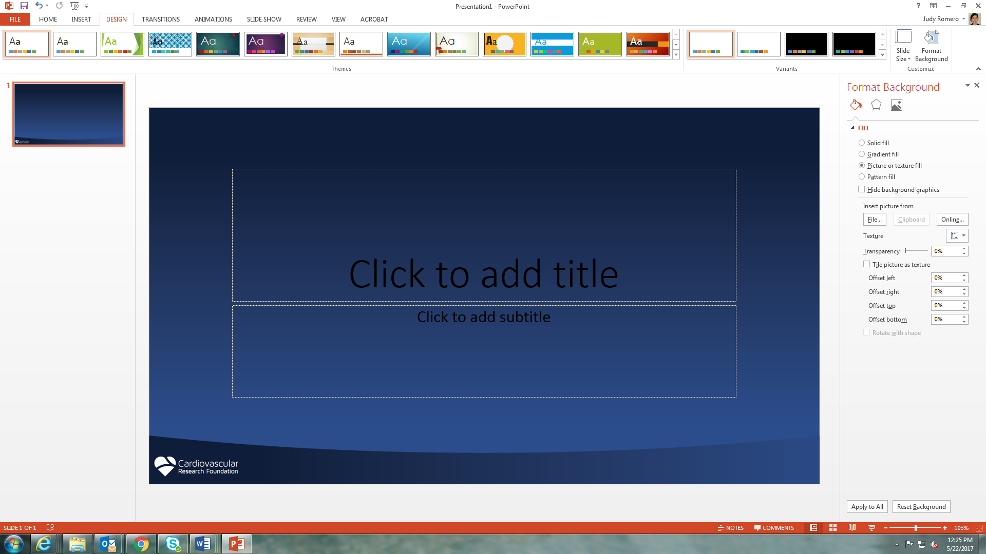

7. Click “Apply to All” at the bottom of the right-hand menu.

8. All the slides in your presentation will have the new background.

